**Table script**

1. **Creating author_imt table**

CREATE TABLE author_imt(

AID NUMBER PRIMARY KEY,

ANAME VARCHAR2(20),

GENDER VARCHAR2(6),

BIRTHDATE DATE,

MOTHER_TONGUE VARCHAR2(13));

Table Name: author_imt

Data File: author_imt

Control File: author_imt

Request Id: 5529717

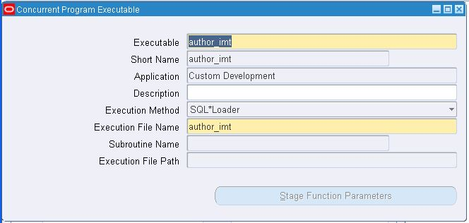

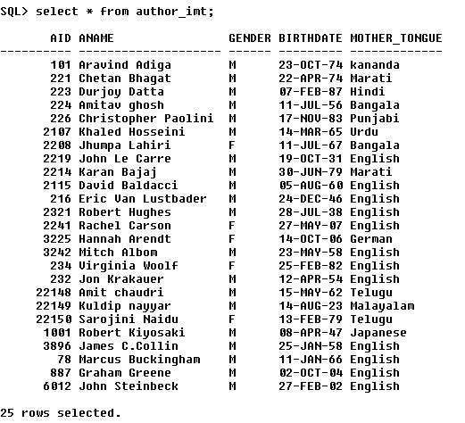

1. **Creating book_imt.dat file (dummy table)**

CREATE TABLE book_imt

( BOOK_NAME VARCHAR2(40),

AID NUMBER REFERENCES AUTHOR_IMT(AID),

ISBN_NO NUMBER UNIQUE,

PAGES NUMBER,

COST NUMBER,

PUBLISH_DATE DATE,

BOOK_TYPE VARCHAR2(12)

);

Table Name :book_imt

Data File :book_imt

Control File :book_imt

Request Id :5529718

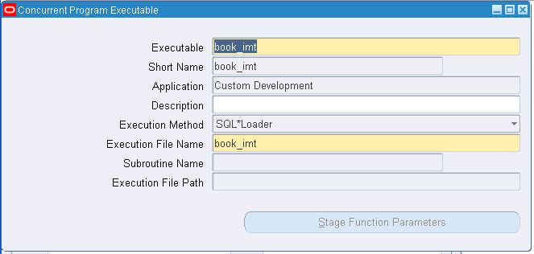

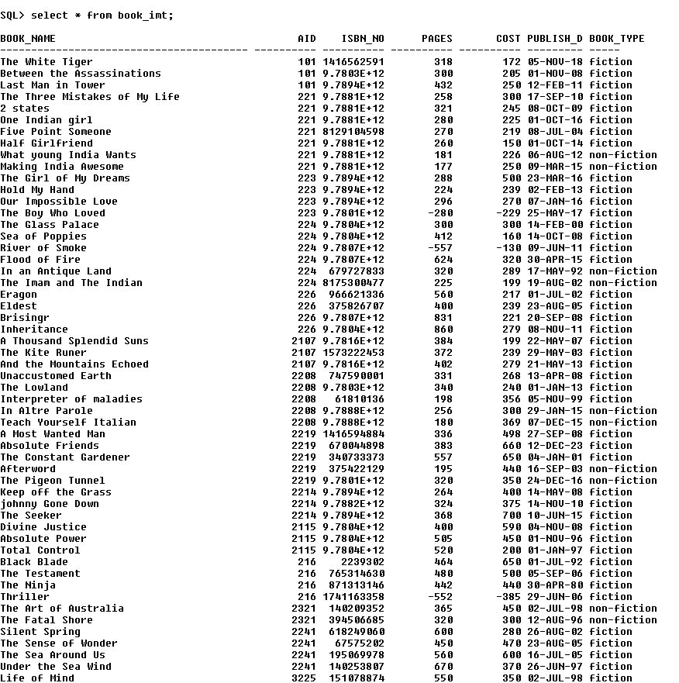

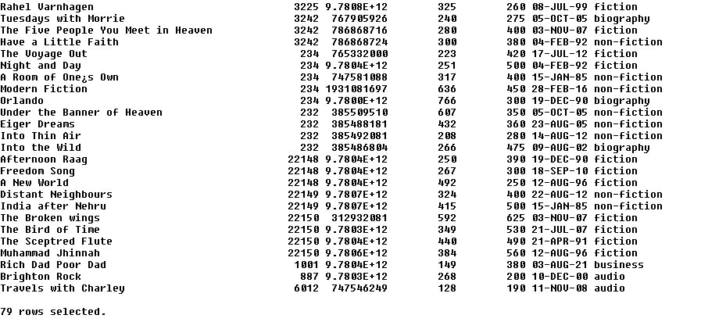

1. **Book master table - book_master_imt**

create table book_master_imt

( book_id number,

book_namevarchar2(50),

author_id number,

isbn_no number,

pages number(4),

cost number(5),

publish_date date,

book_typevarchar2(12)

);

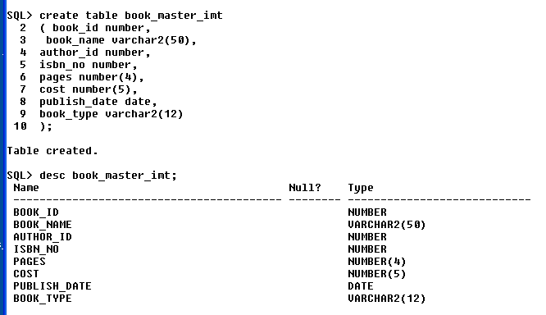

1. **Sequence for book_id - b_id**

create sequence b_id

start with 1000

maxvalue 99999999

minvalue 1000

increment by 1;

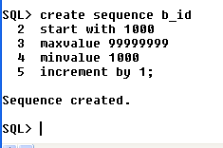

1. **Package body and spec created**

**Package name -book_master_pimt**

**Request Id :5529771**

**Package specification Coding :**

create or replace package book_master_pimt

is

procedureloadtable (errbuf out varchar2, retcode out number);

functionvalidate_author_id ( id number) return boolean;

functionvalidate_isbn (isbn number) return boolean;

functionvalidate_pubdate(pub_date in out date) return date ;

functionvalidate_type(b_type varchar2) return boolean;

end book_master_pimt;

/

**Package body Coding:**

create or replace package body book_master_pimt

is

procedureloadtable (errbuf out varchar2, retcode out number)

is

cursor c1 is select BOOK_NAME,AID ,ISBN_NO ,PAGES ,COST,PUBLISH_DATE,BOOK_TYPE from book_imt;

bookbook_imt.book_name%type ;

idbook_imt.aid%type ;

isbnbook_imt.isbn_no%type;

pagebook_imt.pages%type;

ratebook_imt.cost%type;

pub_datebook_imt.publish_date%type;

b_typebook_imt.book_type%type;

BEGIN

open c1;

loop

fetch c1 into book,id,isbn,page,rate,pub_date,b_type;

exit when c1%notfound;

if(validate_author_id(id)) then

if(validate_isbn(isbn)) then

if(page > 0 and rate > 0) then

pub_date := validate_pubdate(pub_date);

if(validate_type(b_type)) then

insert into book_master_imt(book_id,book_name,author_id,isbn_no,pages,cost,publish_date,book_type)

values(b_id.nextval,book,id,isbn,page,rate,pub_date,b_type) ;

end if;

end if;

end if;

end if;

end loop;

close c1;

endloadtable;

functionvalidate_author_id ( id number) return boolean is

ctr number;

BEGIN

select count(aid) into ctr from author_imt where id=aid;

if(ctr>= 1) then

return true;

else

return false;

end if;

endvalidate_author_id;

functionvalidate_isbn (isbn number) return boolean is

ctr number;

BEGIN

select count(*) into ctr from book_master_imt where isbn_no = isbn;

if(ctr = 0) then

return true;

else

return false;

end if;

endvalidate_isbn;

functionvalidate_pubdate(pub_date in out date) return date is

BEGIN

if(pub_date>sysdate ) then

returnsysdate;

else

returnpub_date;

end if;

endvalidate_pubdate;

functionvalidate_type(b_type varchar2) return boolean is

BEGIN

if(b_type = 'fiction' or b_type ='non-fiction' or b_type = 'business' or b_type = 'audio') then

return true;

else

return false;

end if;

endvalidate_type;

end book_master_pimt;

/

